#### Systems Analysis and Design (INFO 1113)

#### Assignment 3

#### Balwinderpal Singh

#### Student id number :100398257

#### Email: Balwinderpal.singh@email.kpu.ca

#### Instructor: Dr. Abhijit Sen

URL for my site is:

<https://sites.google.com/view/getyourspace-software/home>

Trello Link

<https://trello.com/b/6YFNlzRL/assignment-3-group-project-tasks>

GitHub link

<https://github.com/Balwinderpal/Assignment3>

GitHub group link

<https://github.com/group-d-parking-app/new>

**Introduction**

For our project, we are designing an a application allows users to get access through their smartphone app to real time of parking spots information helping them get to where they need to faster and more efficiently. It also helps reduce congestion in parking garages and the number of emissions from engines circling to find a spot. Its convenience that will make people use that application like real-time information about available spaces, entrances, exits and more, users will spend less time searching for a place to park. User can get live updates like how much time they have left before their parking pass expires. In this application you also get to know about how much parking fee you must pay if there are two or more parking places near your location it will also compare the parking charges for you so you may get experience in cheaper price. With our application, not only will you be able to access these things, but you may also submit feedback on your experience.

**List of functions:**

**Functional:**

* Display map/GPS
* Submit a Reviews /Feedback(experience)
* View Filters (prices, parking size required)
* Rate card (include the prices of parking spaces available on daily, weekly, or monthly basis)
* Vehicle tracking
* Car location tagging
* Cashless payments
* Display parking location information

**Non-Functional:**

Receives parking discounts for using app.

* Allow users to reserve parking.
* Services (hours/availability)
* Capacity of parking place
* View images of parking location

## Use Case Diagram:

## 

## Use Case Descriptions:

|  |
| --- |
| use case title: Choose filters for different restaurants |
| Primary Actor: Customer |
| Level: kite |
| Stakeholders: anybody |
| Precondition: Customer must access the website |
| Minimal Guarantees: will give error to refresh the website |
| Success guarantees: Given filters |
| Trigger: Customer must access the website. |
| Main success Scenario:Customers searches for the parking locations.All the available slots are shown.Customers can make a cashless payment.Customers also complain if someone parked wrong. |
| Extensions:Map dose not load on website.Customers refreshes website and tries again.Customers quits site.Filters do not filter the map properly.Customers looks for parking with cheaper price.Customers quits site. |
|  |

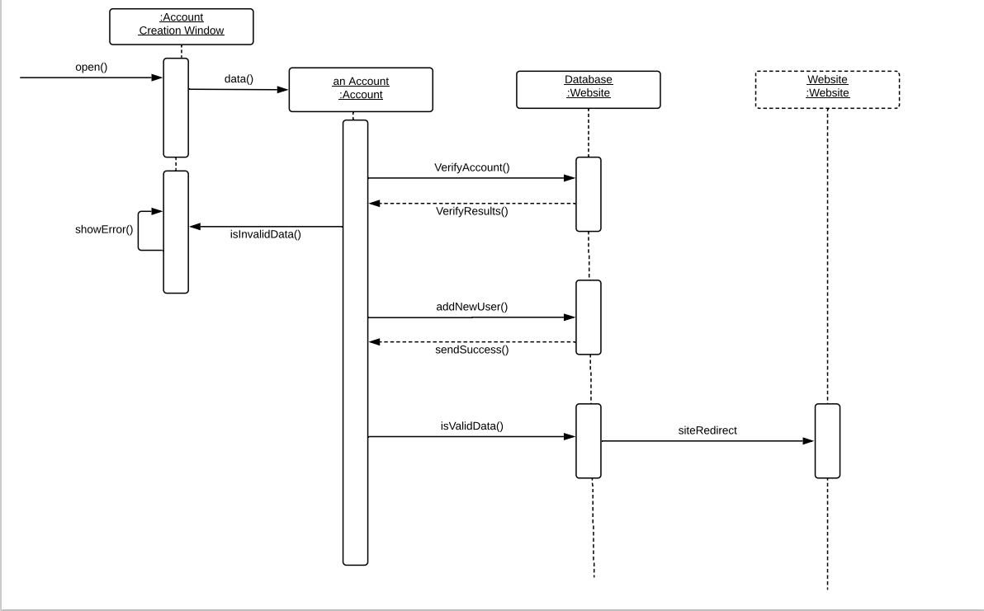 sequence diagram